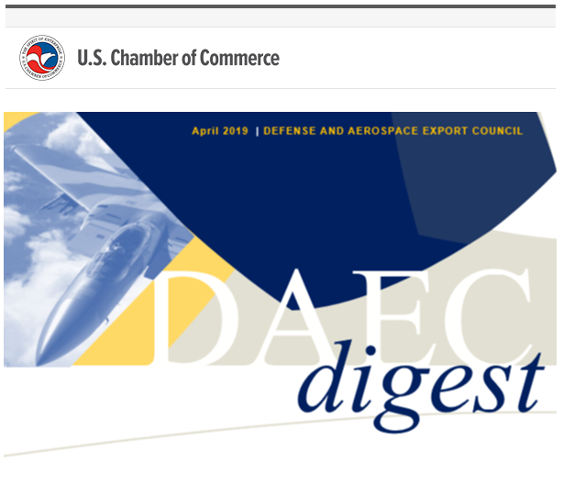
2019 Munich Security Conference
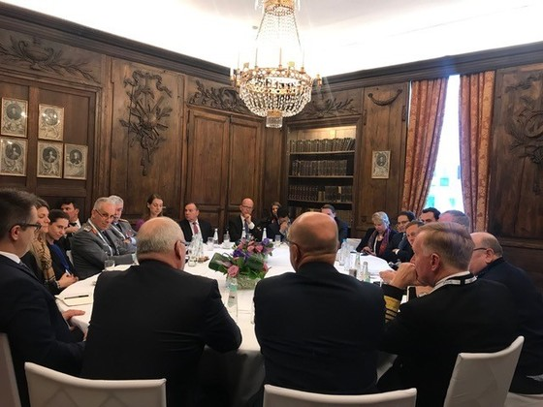
In February, Keith Webster attended the 2019 Munich Security Conference to gain insight into issues and trends that impact our Defense and Aerospace Export Council members. The conference focused on the rise of China and its threat to the liberal world order, the collapse of trust in multilateral and bilateral relations, and a technological cold war between the U.S. and China. Strengthening NATO and the EU was Germany’s premier objective for international security, and it was stated that to do so the EU must carry more weight, NATO must uphold fairness in the trans-Atlantic relationship, and NATO’s defense needs and contributions must be measured by more than 2% of GDP investments.
German Chancellor Angela Merkel asserted the need to develop a consistent and coherent European defense policy in conjunction with NATO as well as a “need to harmonize for defense industries within the EU”. For a detailed readout, we ask that DAEC members contact Katie Holzman.
Keith participated in a closed door, invitation-only session focused on emerging threats and defense innovation, which was hosted by General (retired) David Petraeus and former Deputy Secretary of Defense Robert Work.
CAT I UAS Meeting with Peter Navarro
On February 4, DAEC met with Dr. Peter Navarro, Assistant to the President, Director of Trade and Industrial Policy, and Director of the White House National Trade Council to seek his support in motivating the State Department to implement a revision to their CAT I UAS export policy quickly. Since April 2018, the administration has worked within the Missile Technology Control Regime (MTCR) member community to secure regime member support for a U.S. revised policy that liberalizes CAT I UAS sales. Assistant Secretary of State Chris Ford led the U.S. delegation in a MTCR member meeting in early December 2018 and failed to secure member support. We had predicted this failure to secure support, and our position has been to fail fast and move on to a Plan B export policy plan to be unilaterally implemented by the U.S.—an option the U.S. has within the MTCR framework. We believe the State Department is considering a number of Plan B options but lacks a sense of urgency. We briefed Navarro on our recommended Plan B (to treat UAS platforms as aircraft vice missiles) to impress the need for urgency.

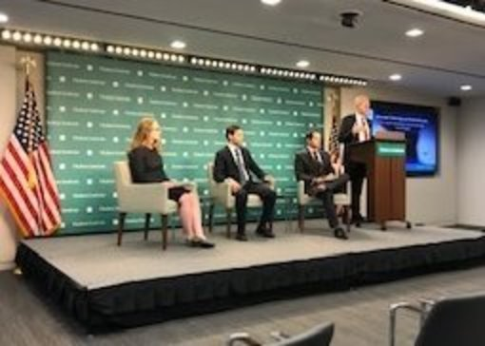
“Autonomy, Technology, and National Security: The Case for Reforming the Missile Technology Control R” at the Hudson Institute
On February 12, DAEC Executive Director Ben Schwartz spoke at the Hudson Institute on MTCR reform alongside University of Pennsylvania Professor Dr. Michael Horowitz and the Heritage Foundation’s Rachel Zissimos. This discussion can be streamed here.

UAS Meeting with John Sullivan
On February 26, DAEC met with Deputy Secretary of State John Sullivan to discuss the Administration’s lack of progress since the policy announcement last April. Sullivan informed us he left this issue months ago with the proposed introduction of the new CAT I criteria specific to speed, which he believed would open up market share for American companies. Webster explained our preference is reclassifying UAS as aircraft rather than missiles, while also welcoming any change that opens up market share as an interim step. Sullivan tasked his staff to schedule the Hon. Andrea Thompson, Under Secretary for Arms Control and International Security and Hon. Chris Ford, Assistant Secretary for International Security and Nonproliferation to update him on this issue. Sullivan thanked the Chamber for bringing this matter to his attention and commented in closing that the last thing the President wants to hear is that something is taking this long.

Foreign Sale Financing Speed Rounds with State
In December, Deputy Assistant Secretary Marik String offered 10-15 minute one-offs with DAEC members to discuss their concerns and ideas on foreign sales financing. We have secured Thursday, April 18 2-3PM on his calendar and are lining up time slots for members interested in participating. For more information, please contact Katie Holzman at KHolzma@USChamber.com.
Engagement on the Hill
DAEC is accelerating congressional outreach. We met with Senate Committee on Foreign Relations staff on March 12th for a deep dive on our work. Subsequently, the Senate Committee on Foreign Relations and Committee on Armed Services agreed to host DAEC for a roundtable discussion this spring (date TBD) and to include staff from the House as well. We will provide an overview of our mission and policy agenda in an effort to locate areas for partnership. Through these engagements we are able to refine our Congressional engagement, advise our members of support and pitfalls while building coalitions.
Partnership with Reagan Institute
DAEC is pleased to announce a partnership with the Reagan Institute on studies pertaining to National Security, Innovation, and Industry. We look forward to providing insight and sharing updates on these issues when and where they are relevant with our members. Specifically, DAEC will serve as an advisor to the Institute on their recently announced task force: 21st Century National Security Technology and Workforce. You can learn more about this task force by going to the Reagan Institute's website.
Bilateral discussions
In January, Keith was invited by the Canadian Embassy staff to a meeting with Marvin Hildebrand, Canada’s Economics Minister to the United States and Ambassador David MacNaughton to discuss U.S. Canada trade and defense relations. The bi-lateral challenges were discussed at length and critical information regarding Canadian political reaction to include changes to their acquisition policies were passed, with Canada’s support, to the Administration. This meeting was immediately followed by a broader round table discussion lead by Ms. Joanne Lostracco Director, Continental Material Cooperation (DND) and her team with a focus on the future of U.S. Canadian defense cooperation.
In March, Keith was invited to join India’s visiting Foreign Secretary Vijay Gokhale in an intimate luncheon discussion on the state of U.S. - India relations. Also participating in this lunch were India’s Ambassador to the U.S. Harsh Shringla, India’s Deputy Chief of Mission Santosh Jha, Hon. William Cohen, Hon. Michele Flournoy, former U.S. Ambassador to India Richard Verma and President of the U.S. India Business Council Hon. Nisha Biswal. General consensus was that the bilateral relationship remains strong and that various contemporary policy positions of both the U.S. and GOI, which present some political challenges for each, are not insurmountable.
In March, Keith was invited to dinner with Finish Ambassador to the U.S. Kirsti Kauppiof and Mr. Jukka Juusti, Permanent Secretary at the Ministry of Defense of Finland, to discuss Finnish – U.S. defense cooperation including acquisitions and the transatlantic relationship.
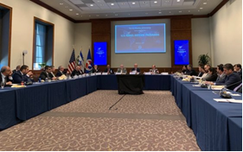
In March, Keith moderated a panel at the U.S. Chamber on U.S. Israeli Defense industrial cooperation. The panel included Dave Drabkin Chairman of the Section 809 Panel, Charlie Williams Jr. Commissioner on the Section 809 Panel and Jeff Bialos Partner, Eversheds Sutherland. The participants were Israeli business executives and Embassy staff seeking ways to form industrial partnerships with the U.S. defense supply base.

Advisory Board additions
Moving in to the second quarter, we are proud to announce two new additions to DAEC’s Board of Advisors displayed left to right below , respectively. Tom Nolan joins us as a Partner at Constructive Edge, President of the Covitex Corporation, and Executive Committee member of the Global Offset and Countertrade Association. Tom Callahan, an executive at CRDF Global and former SFRC Senior Staff member, joins our board with an extensive career in federal service and industry. Updated copies of our Advisory Board brochure can be found here.

