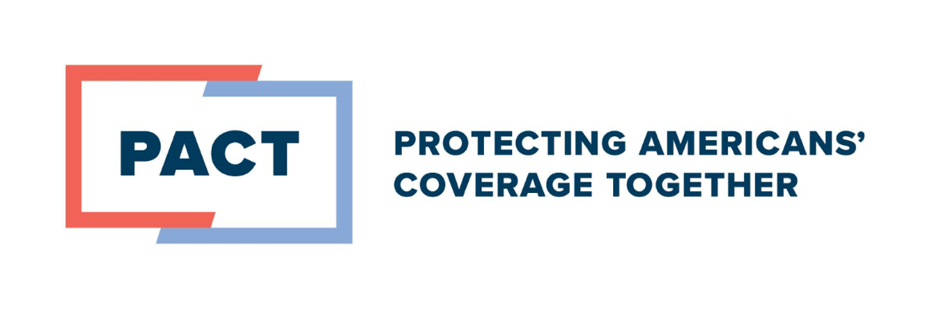
Employers Remain Committed to Offering Robust Health Coverage, Enhance Offerings and Access
Key findings from the 2026 Business Group on Health Employer Health Care Strategy Survey

As employers navigate rising medical inflation, they remain firmly committed to providing robust and high-quality health coverage to their workforce. Employers continue to understand that what is good for their employees is good for them. A new survey released by Business Group on Health underscores this sentiment, finding 82% of employers see navigation to higher-quality providers as an approach to improving care amid rising costs.

As the cornerstone of America’s health system, employer-provided coverage serves nearly 180 million people and it’s overwhelmingly valued by both employers and employees.

Here are three key findings from the 2026 Employer Health Care Strategy Survey:

- Two key pillars – the Employee Retirement Income Security Act (ERISA) preemption and the tax exclusion – are central to employers’ ability to offer comprehensive, high-quality and affordable coverage. An overwhelming majority of employers, 99%, said protecting and affirming ERISA was critically important. And 85% of employers ranked the tax exclusion as one of their top five priorities for the U.S. government.
- Workers – and employers – value mental health offerings. More than 70% of employers saw an increase in the mental health services used by their workers, underscoring the value of employer-provided plans. This trend is expected to continue with 17% percent of employers anticipating an increase in use in the future. As a result of the improvements in access and utilization, it will be important for employers to ensure offerings are high-quality and appropriate for their workforce.
- Employers expanded access to women’s preventative care and enhanced maternity support. In 2026, 58% of employers will expand preventative care for women, an increase of 22 percentage points in just two years, reinforcing how employers are adding and enhancing benefits to meet the needs of the workforce. Menopause support is also on the rise. In 2024, only 28% of employers had menopause programs in place, but 58% of employers reported they will provide menopause support programs and 25% said they will increase these offerings in 2026. Enhancements in doula services, postpartum depression, and support for high-risk pregnancies in under-resourced populations have also been increased over the last year.

Despite rising costs, employers recognize the need to provide comprehensive and affordable care, and they continue to innovate to meet the needs of their workforce and their families. By strengthening and supporting the employer-provided coverage system, we can better protect the ability of employers to offer robust, affordable, and innovative benefits for workers today and in the years to come.

The Protecting Americans' Coverage Together campaign is a coalition that includes the U.S Chamber of Commerce, Business Roundtable, Vermeer Corporation, the National Association of Manufacturers and Council for Affordable Health Coverage. PACT represents leading employer voices focused on strengthening employer-provided coverage and protecting the benefits that American families depend on for their health.



