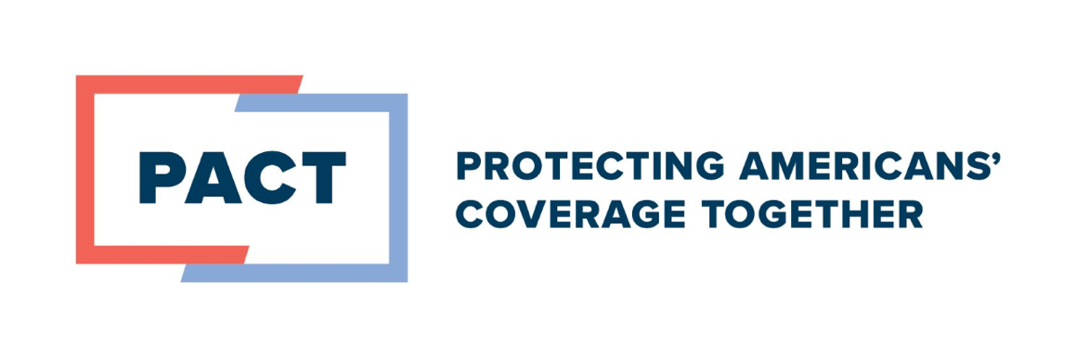
Employers Accelerate Investments in Mental Health Services, Warn of Unintended Consequences of Mental Health Parity Rule

Americans have become acutely aware of the value of mental and behavioral health services, and employers are taking note. In recent years, employers have accelerated investments in mental health offerings in the workplace to meet the evolving needs of today’s workforce. This includes the expansion of in-network behavioral health providers, the growth of telehealth services, and the integration of Employee Assistance Programs, all of which set this coverage apart from other health plans.

In fact, a vast majority of employers (73%) saw an increase in the mental health services used by their employees, further underscoring the value of these offerings in employer-provided plans. Additionally, a recent Mercer survey found American workers are extremely or very concerned about physical, mental or emotional, or cognitive health decline and are interested in benefits that promote mental wellbeing, like mental health screenings and training programs to help address related health challenges.

Although advancements have been made in these types of offerings, barriers to care are still an ongoing challenge and more must be done to find innovative ways to facilitate better access to care. In particular, there remains a vast shortage of qualified mental health providers and many refuse to participate in coverage networks, preferring to run cash businesses.

Unfortunately, while well intended, a rule finalized last year to update how the Mental Health Parity and Addiction Equity Act (MHPAEA) is applied will likely have negative impacts on the availability of quality care. The rule will create significant operational challenges, lower the standards of care by emphasizing volume of care over quality, and reduce innovation in behavioral health coverage by undermining the flexibility in benefit design. Rescinding the rule is the best way to prevent these negative impacts on care.

As the current administration considers whether to modify or rescind the rule, Protecting Americans’ Coverage Together (PACT) also encourages policymakers to consider its three policy recommendations to modernize mental health care, which include expanding access to telehealth, strengthening the provider workforce, and better integrating physical and mental health care.

Employers are finding innovative ways to enhance mental and behavioral health offerings to be more responsive to the needs of their workforce today and in the future. That’s part of the reason it’s the single largest source of health benefits in the U.S., serving more than 180 million American workers and their families.

###

The Protecting Americans' Coverage Together campaign is a coalition that includes the U.S Chamber of Commerce, Business Roundtable, Vermeer Corporation, the National Association of Manufacturers and Council for Affordable Health Coverage. PACT represents leading employer voices focused on strengthening employer-provided coverage and protecting the benefits that American families depend on for their health.


