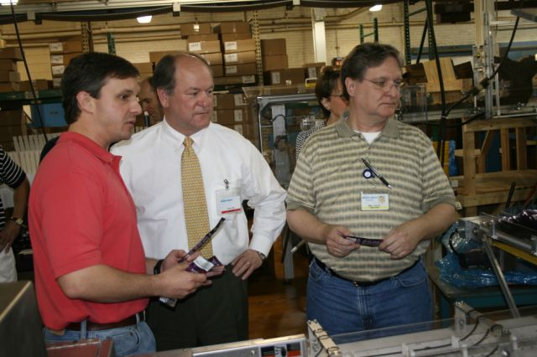

**4. Government Affairs**

1. 4.2 Sample communications made to elected officials.

Attachment: (Site tours) with elected officials to chamber members’ place of business. This helped Congressman Bright learn about recent votes taken on member issues and also the Employee Free Choice Act that is being considered in Congress in 2009.

