advocating the needs of members and
implementing change for competitive advantage.
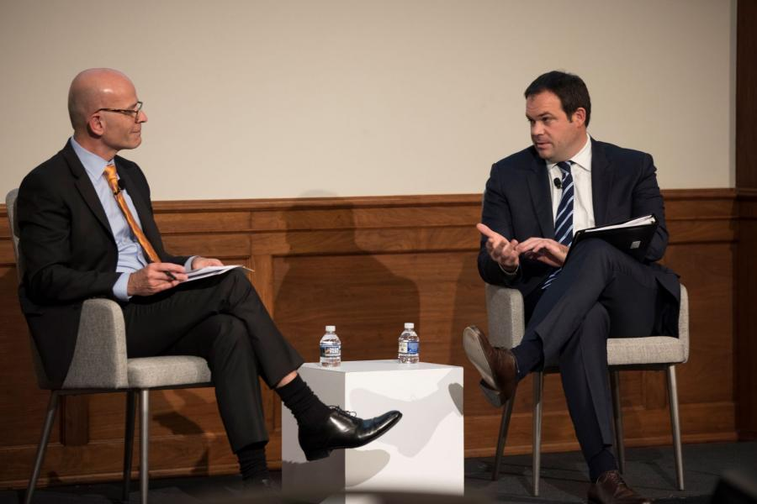
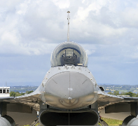
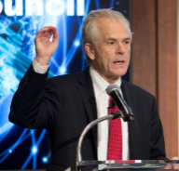

◆ AT A GLANCE………. 1

NOTE TO DAEC MEMBERS:
Chamber CEO and senior Chamber Executives will be visiting the following countries and engaging at the highest levels with government representatives during 2019: China, France, Japan, Egypt, and Israel with others to be confirmed. Members, please contact us as we prepare these individuals engagements to ensure we capture your critical issues.

Executive Board Inauguration
DAEC will celebrate our carefly selected Executive Board over dinner at the U.S. Chamber of Commerce this Spring. We are proud to announce these members who have strategically guided our Council’s agenda toward success with the support and guidance of our Advisory Board. We are expanding our Executive Membership which includes a seat on this board. For more information, please contact Katie Holzman at KHolzman@uschamber.com.

Keith Webster (left) discusses the 2019 Defense Industrial Base Report with Eric Chewning (right).
Our 32 published policy recommendations were well-received by the White House last summer, which framed our engagement with the Administration and Congress. Congressional interest streamlined our ability to shape a number of discussions that impacted our members. DAEC leadership was featured in Defense News and Foreign Policy Magzine on several occasions voicing concerns and goals for the future of U.S. defense exports.
AT A GLANCE

After launching in April, DAEC quickly picked up momentum, members, and a media presence with special thanks to the support of our corporate sponsors.

DAEC
◆ UAS Plan B Engagement…………..2

◆ Muncih Security Conference…………..2

◆ In case you missed it…………..2

◆ Executive Board InaUguration… 1

January 2019 | Edition 2

digest
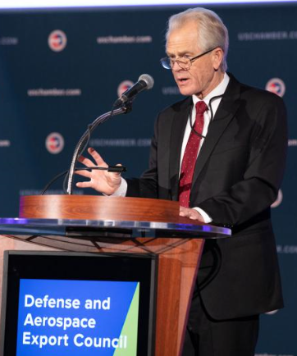
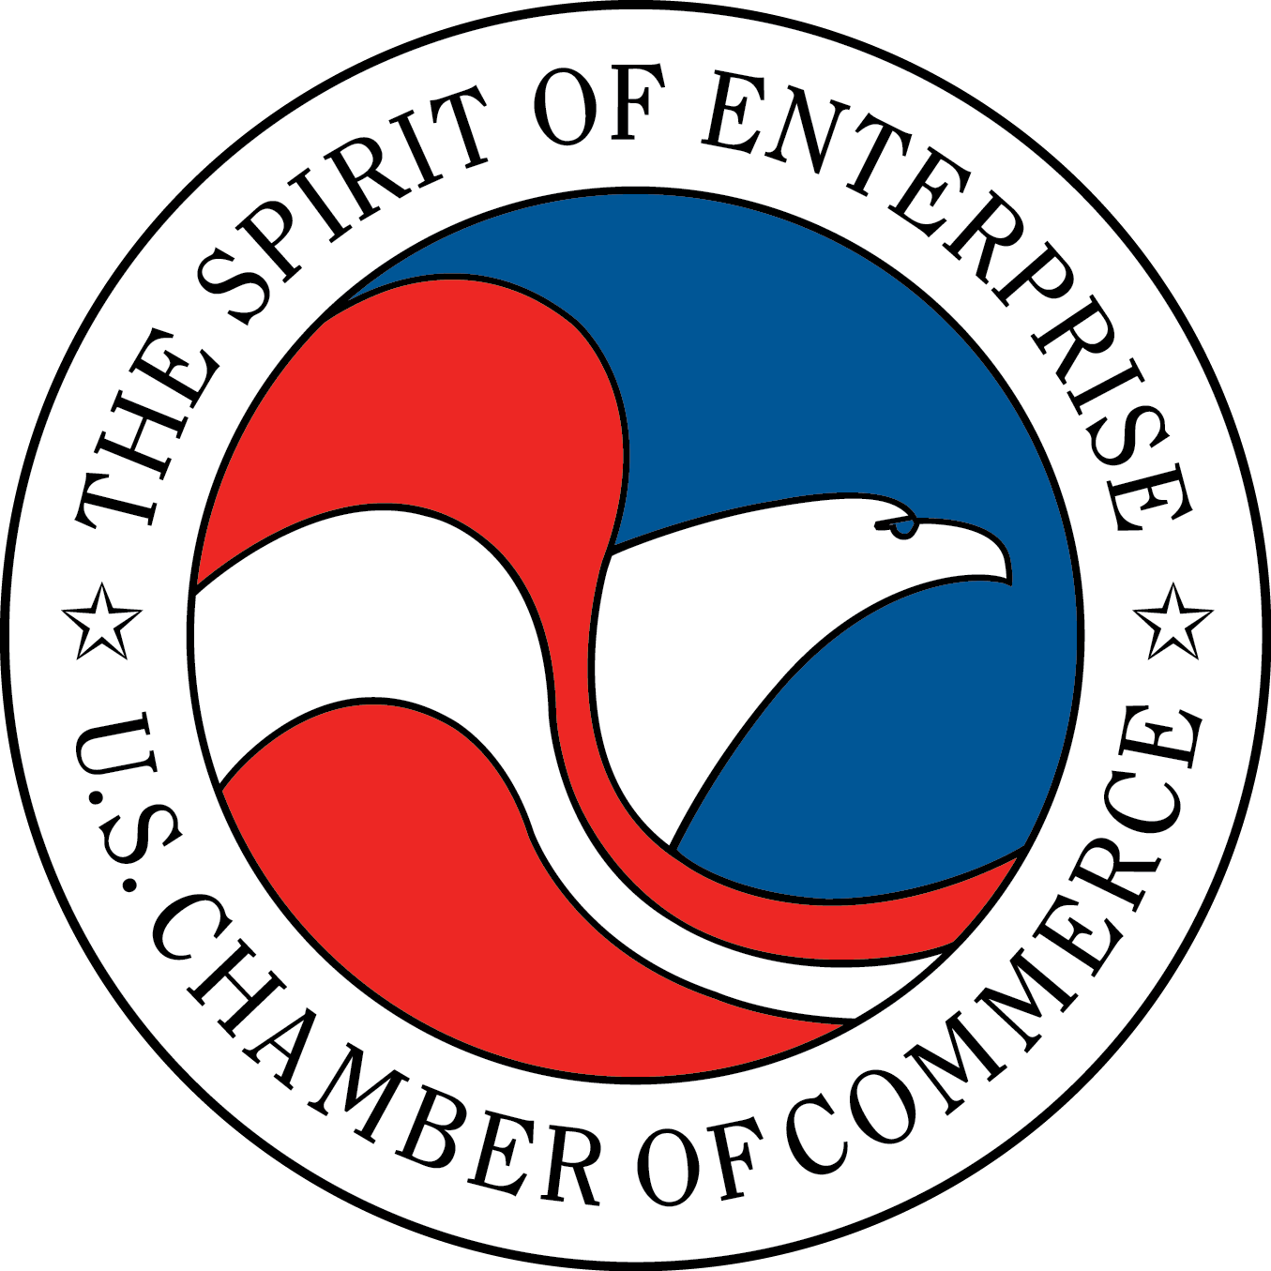
Prior to the January reception, DAEC President Keith Webster met with Canada’s visiting Economic Minister Hildebrand and co-chaired a round table discussion with Canadian Director, Continental Material Cooperation Joanne Lostracco to discuss the Canadian and U.S. defense relationship, military requirement trends for next generation capability and bi-lateral industrial cooperation.

Peter Navarro delivers remarks on DAEC’s official launch at the U.S. Chamber of Commerce in April.
The DAEC is focused on next steps regarding Unmanned Aerial Systems export policy now that the USG proposal to reform the MTCR has stalled. While we understood the rationale behind the MTCR reform effort, it always appeared to be a long shot given the divergent interests of the United States and Russia as well as other countries without a competitive UAS manufacturing industry. The DAEC will continue engaging interested parties in the executive branch and in Congress on this issue as we work to arrest the increasing loss of global market share for American UAS manufacturers.
This February, DAEC President Keith Webster will be attending the Munich Security Conference alongside hundreds of senior decision-makers from around the world, including heads of state, ministers, C-suite executives, and international and non-governmental organizations. Members will receive a detailed de-brief on the conference upon Keith’s return.

DAEC President Keith Webster and Executive Director Ben Schwartz joined industry and association executives at the Baker McKenzie hosted luncheon discussion on Mitigating Supply Chain Risks in the Aerospace and Defense industry sector. Cyber, export controls and sanctions, CFIUS, customs enforcement and anti-corruption compliance were key topics of discussion with expert advice provided by the Baker McKenzie legal team.

DAEC President Keith Webster joined retired Admiral Gary Roughead as key note speaker at the Council on Foreign Relations U.S.-India Study Group moderated by CFR’s Ambassador Blackwill. Joining the discussion were representatives from various Universities, think tanks, associations and the US Government. Discussion topics included the state of current defense relations, geo political context of the U.S.- India relationship, challenges and successes.

White House Director of Trade and Industrial Policy Dr. Peter Navarro and Deputy Assistant Defense Secretary for Manufacturing and Industrial Base Policy Eric Chewning joined us for a discussion on the defense industrial base and what the Trump administration is doing to improve it. Watch C-Span’s coverage here. Under Secretary Andrea Thompson joined us for an intimate closed-door roundtable with our members to discuss CAT policy changes and implementation.

To receive more information or invitations to future DAEC events, please contact Katie Holzman at KHolzman@USChamber.com.

In case you missed it…

1615 H ST., NW
Washington, D.C. 22062
Defense and Aerospace
Export Council
Munich Security Conference
Canada’s Annual Defense Trade Reception 2019
UAS Plan B Engagement

Lorem ipsum dolor sit amet, consectetuer dolor te diam wisi nibh euismod tincidunt ut laoreet, wisi ut laoreet dolore magna aliquam erat volutpat.

