B20 Tokyo Summit Joint Recommendations
"Society 5.0 for SDGs" (Final Draft)

As of 26 February 2019
Secretariat of the B20 Tokyo Summit

I. Basic Recognition of the World Economy and Our Vision of a Future Society 1
1. The most imminent challenges at a global level 1
2. Realising "Society 5.0 for SDGs" 1
3. B20 Tokyo Summit Principles 3

II. Policy recommendations to realise Society 5.0 for the SDGs 4
1. Digital transformation for All 4
(1) Develop policy frameworks to utilise data 5
(2) Promote international cooperation in the field of cybersecurity 6
(3) Accelerate digital transformation throughout society 6
(4) Promote AI utilisation with trust 7
(5) Launch real world projects 8
2. Trade and Investment for All 8
(1) Reform the WTO 8
(2) Strengthen international rules 9
(3) Establish comprehensive and high-standard FTAs 11
(4) Promote cross-border investment 11
3. Energy and the Environment for All 13
(1) Realise low emissions in the society on a global scale and in the long-term 13
(2) Establish a Sound Material-Cycle Society 15
(3) Realise a society in harmony with nature 16
4. Quality Infrastructure for All 16
(1) Effective mobilisation of financial resources 16
(2) Take measures to promote the quality infrastructure 17
5. Future of work for All 18
6. Health and well-being for All 19
(1) Promote digitalisation 19
(2) Universal Health Coverage 19
(3) Improve pandemic preparedness and response 20
(4) Support business' voluntary initiatives to promote health and productivity management 20
(5) Ensure healthy lives and promote well-being in the era of aging populations 20
7. Integrity for All 21

III. Businesses for All 22
1. "B20 Business Voluntary Action Plan" 22
2. Enhance communication with relevant stakeholders as appropriate 22

IV. Conclusion 23

Basic Recognition of the World Economy and Our Vision of a Future Society

The most imminent challenges at a global level: Towards sustainable and inclusive development

Downside risks are becoming apparent due to growing trade conflicts and geopolitical tensions, leading to a slowdown in the steady expansion of the world economy. The world which is not fully governed by international rules are spreading even in the realm of trade. Populism is on the rise due to various factors. These issues pose serious challenges to the existing governance structures. To overcome these challenges in a steadfast manner, the rules-based, free, fair and open international economic order needs to be strengthened through enhanced policy coordination, updated rules and increased compliance. In parallel, each country should undertake necessary structural reform in a decisive manner.

Furthermore, the world continues to face fundamental mid- and long-term challenges. These include poverty, hunger, insufficient or inadequate education affecting employability, persistent unemployment particularly in the youth segments, informality, gender inequality, demographic change affecting social protection, constraints on natural and energy resources, and climate change. All of these should be addressed as top priorities without delay. Actions should be taken immediately. To tackle these issues and realise sustainable and inclusive development, regardless of gender, age, ethnicity, and religion, it is essential to set our goals high. Governments should mobilise appropriate policy tools to achieve them at sub-national, national and international levels, better promoting the achievement of Sustainable Development Goals (SDGs) within the society.

Businesses of all sizes across all sectors, national/sub-national public authorities and other stakeholders, play a critical role in accordance with their capabilities in ensuring that necessary resources should come forward to achieve sustainable and inclusive development. Such resources including human, financial, and intellectual capitals cannot be fully mobilised unless the current unpredictability is dissipated.

Ten years after the global financial crisis, there is no time like the present to require international cooperation in which the G20 can play a more important role. We, the B20, representing the voice of businesses in the G20 countries and regions, present here our future vision for which our society should be heading. We are looking forward to the Osaka Summit with great expectation for the G20 Leadership in these difficult and challenging times.

Realising "Society 5.0 for SDGs"

Continued and steady progress needs to be made towards achieving the SDGs which define a set of 17 goals applicable to every country, ensuring that all people enjoy peace and prosperity. The B20 support the SDGs to tackle the world’s most pressing social, economic, and environmental challenges in the lead-up to 2030 and beyond. The SDGs provide all businesses with new lens through which to translate the world’s needs and ambitions into business solutions. Business drives innovation, provides a source of finance and constitutes an engine for economic development and employment. The pace of SDGs implementation must be accelerated.

To this end, governments should encourage the adoption of digital technologies while paying due attention to its economic and social impact, such as Internet of Things (IoT), fifth-generation mobile communication system (5G), Big Data, cloud computing, Artificial Intelligence (AI), robotics, and blockchain, to break down silos, thereby increasing competition and consumer welfare. Governments, business, and civil society in the G20 need to put their creativity to work to solve economic and social challenges and to create new values. This will lead us to the next stage of humankind, namely "Society 5.0", following the Hunting Society (1.0), the Agrarian Society (2.0), the Industrial Society (3.0), and the Information Society (4.0).

[Figure 1 Society 5.0]
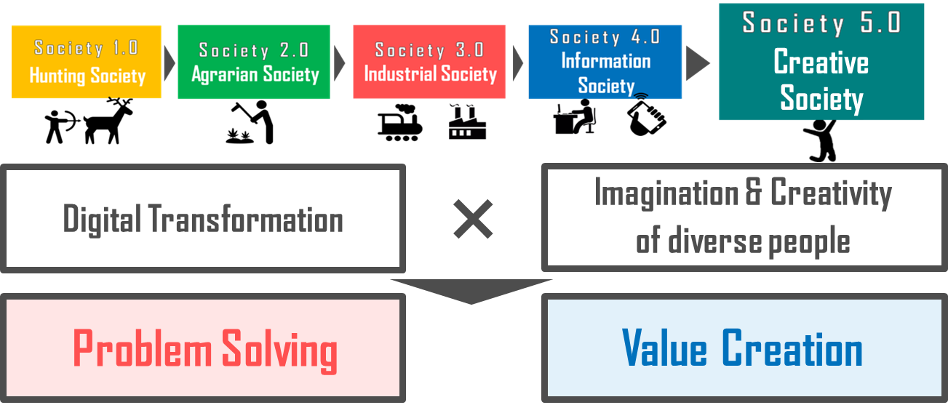
Source: Society 5.0— Co-Creating the Future- (Keidanren)

We recognise that there are challenges about the potential effects that digitalisation might bring, such as substantial change in the content of job, increase of social disparities caused by data hoarding, and potential risk of a surveillance society with substantial loss of privacy. However, we believe that effective use of IoT, Big Data and AI enables us to harness true human creativity and create a new society of the future using cutting-edge technologies. The benefits resulting from the use of these technologies include; (1) finding insights in data difficult for the human eye to see; (2) automatically identifying patterns and detecting anomalies in the data; (3) realising greater accuracy; (4) increasing operating efficiency and predicting equipment failure; (5) enhancing risk management; (6) avoid costly unplanned downtime for a number of industries; and (7) enabling new and improved products and services. At the same time, we recognise the necessity of public-private collaboration so that no one will be left behind by this transformation. For this purpose, it is imperative for governments to take concrete and immediate policies and measures in the seven areas which are set out below.

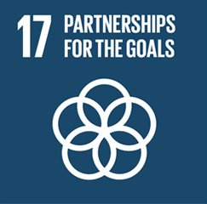
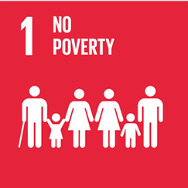
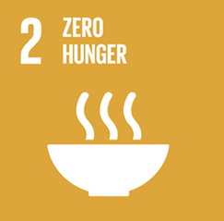
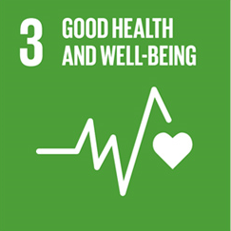
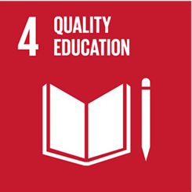
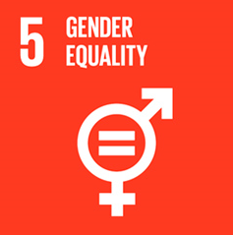
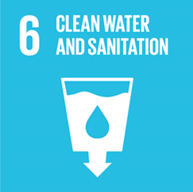
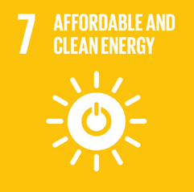
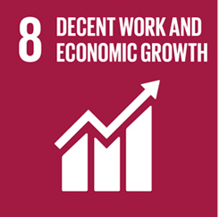
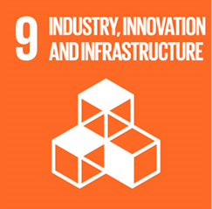
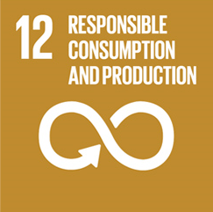
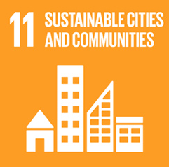
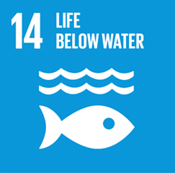
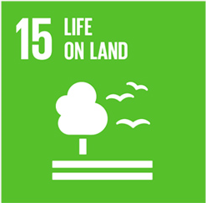
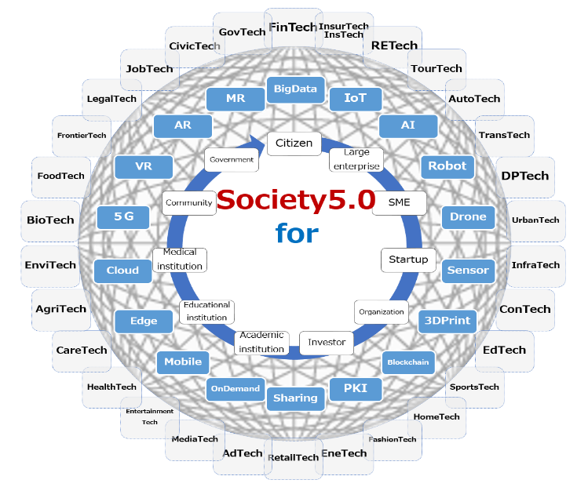
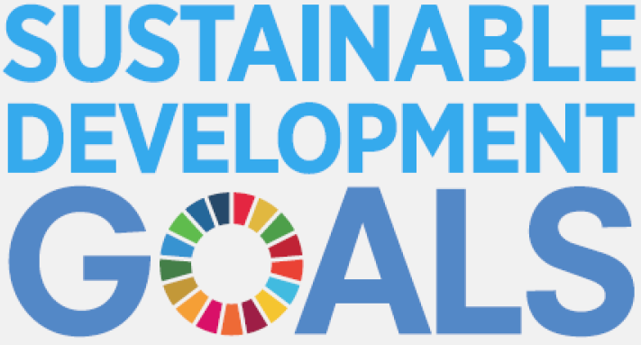
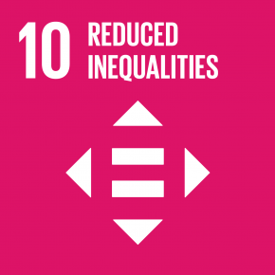
[Figure 2 Society 5.0 for SDGs]

B20 Tokyo Summit Principles

We, the B20, recommend the G20 to positively consider our following joint recommendations and to implement them to achieve the SDGs through realising Society 5.0. Concrete policies and measures for implementation to realise Society 5.0 for SDGs should be based and monitored on the following principles, namely the "B20 Tokyo Summit Seven Principles."

Policies and measures should be:
- Sustainable to achieve the SDGs
- Inclusive to ensure diversity
- Future-oriented to avoid short-sightedness in a rapidly changing world
- Business-driven to promote business' creativity, innovation and entrepreneurship, regardless of their size, sector or region
- Transparent to ensure accountability and integrity
- Rules-based to provide predictability and consistency
- Multilateral to provide solutions to global issues through cooperation and dialogue among various countries and stakeholders

Policy recommendations to realise Society 5.0 for the SDGs

In order to realise Society 5.0 for the SDGs, it is essential to foster innovation and ensure that its benefits are spread throughout society.

It is critical to design policies that foster innovation and spur investment that is achieved through the combination of multi-disciplinary and multi-sourced knowledge. Thus, governments should promote an innovation ecosystem that brings together established businesses, start-ups and academia, and enhance research and development through incentive policies.

In addition, in order to spread the outcomes of innovation throughout society and achieve inclusive, well-balanced and sustainable growth, it is imperative to ensure diversity and close the gender gap, strengthen Micro, Small and Medium Enterprises (MSMEs) capacities and integrate them into the global economy, and promote the growth of developing countries including least developed (LDCs) and middle-income countries, thereby closing the development gap among countries. In this respect, the G20 initiative on Supporting Industrialisation in Africa and LDCs under the Chinese G20 Presidency should continue to be implemented and the Compact with Africa initiated under the German G20 Presidency should be implemented and closely monitored. Furthermore, it is important to promote the G20 Food Security and Nutrition Framework, an initiative enhanced under the Argentine Presidency, to achieve a world free of hunger and malnutrition, thereby meeting the most basic human needs for inclusive growth. In this respect, it is also crucial to incorporate public-private instances of dialogue and collaborative work in the design and implementation of public policies, particularly regarding malnutrition.

In implementing the following policy recommendations through enhanced international cooperation, developing countries and LDCs in particular can achieve leap-frog development, taking advantage of the cutting-edge technologies and realising Society 5.0.

Digital transformation for All

Ensuring connectivity available to all is instrumental to enjoy the benefits of digital transformation. Governments should continue to put connectivity for all on top of their agenda. Especially, the fifth-generation mobile communications system is a key pillar for accomplishing Society 5.0. Governments should establish policy frameworks to encourage necessary investment from businesses and to ensure that digital infrastructure will be available to all including MSMEs on a sustainable and market-oriented basis without delay. To this end, GICA (Global Infrastructure Connectivity Alliance) is expected to contribute to making digital infrastructure asset class.

In order to tackle various global challenges such as natural disaster and infectious diseases, it is vital to combine a huge amount of trustworthy data across borders. Access to reliable data and capabilities to analyse Big Data play a key role in making digital transformation beneficial for all. To this end, we, the B20, put a particular emphasis on the recommendations with a cross-border dimension among others.

As the world continues to urbanise, in order to tackle the global issues and realise sustainable development, it is required to successfully manage urban growth. To this end, we, the B20, propose that smart cities be a focus of the G20’s efforts to implement Society 5.0 for SDGs. This initiative should not be narrowly focused on developed countries but contribute to solutions for the vast number of large cities in developing countries as well.

Develop policy frameworks to utilise data

- Establish the next generation data governance framework
From the perspective of fostering e-commerce, it is prerequisite to accord non-discriminatory treatments to digital products and services, and not to impose customs duties on electronic transmissions. Moreover, in light of national laws and regulations that differ from country to country, priority must be given to the following items in establishing the next generation data governance framework.
- Promote international interoperability of risk-based security and privacy protection standards across jurisdictions so as to ensure free flow of data, information, ideas and knowledge across borders, while respecting applicable legal frameworks for privacy, data protection, and intellectual property rights.
- Foster e-commerce by ensuring independent business decision regarding the location of computing facilities and confidentiality of corporate information.

The G20 should to encourage the development of methods for data utilisation by the private sector, making use of the next generation technologies such as blockchains.

- Realise a WTO rule on electronic commerce
While digital economy has been rapidly expanding, current WTO rules cannot adequately address today’s challenges. In this context, we, the B20, take note of the progress achieved under the Joint Statement on Electronic Commerce by 76 members, issued on 25 January 2019. To capture the change in real business and ensure business-friendly environment, we support the timely launch of WTO negotiations on trade-related aspects of electronic commerce and encourage the members concerned to work in an innovative, open and inclusive manner to achieve a high standard outcome with the participation of as many members as possible.

The G20 should make every possible effort to keep electronic commerce high on the agenda of various international fora.

- Achieve a multilateral consensus on taxation in a timely manner
The G20, together with the OECD-led Inclusive Framework on BEPS (Base Erosion and Profit Shifting), should achieve a multilateral consensus to address the tax challenges arising from digitalisation in a timely manner to ensure a globally fair, sustainable and modern international tax system that incentivises investment, job creation and economic growth. Countries should refrain from adopting unilateral actions before a multilateral framework has been developed.

The economy is rapidly shifting to a digital economy. Long-term solutions should be income tax which can be applied to the boarder digitalised economy and follow the principle of proportionality, avoid distortion, reduce instances of double taxation (including through effective dispute resolution mechanisms) and seek to minimise the administrative burden on taxpayers and tax administrations.

Promote international cooperation in the field of cybersecurity

Globally coordinated approaches to cybersecurity are indispensable to business operation and global economic growth. The G20 should work closely to achieve the following.
- Adopt voluntary, risk-based cybersecurity frameworks in parallel to regulatory approaches that do not stifle innovation nor place unnecessary burdens on business.
- Promote the harmonisation and simplification of incident reporting to meet specific end goals without introducing new risks to the ecosystem.
- Develop/operate consistent or interoperable frameworks to manage ICT risks along the entire global supply chain and leverage voluntary global security standards (e.g. ISO standards) to support the implementation of interoperable cybersecurity measures.
- Provide incentives for companies to voluntarily strengthen their cybersecurity.
- Encourage meaningful and voluntary cross-border information sharing programmes on cyberattacks and cybersecurity incidents across different firms and sectors to learn from each other and defend more effectively through sharing best practices.
- Utilise meaningful and voluntary public-private partnership efforts to defend their citizens, industries and public bodies against cyberattacks by state and non-state actors. Enhanced cooperation among G20 countries as well as in international fora such as the UN Group of Governmental Experts on Cybersecurity is crucial to this end.
- Foster education about cybersecurity for citizens regardless of age, gender or origin.

Accelerate digital transformation throughout society

- Increase social adoption
Recognising opportunities associated with digital technologies, the G20 should not only reduce barriers which impede the use and adoption of digital tools and information services but promote measures to enhance confidence of society through the following measures.
- Promote and secure access to quality education and life-long learning opportunities that consider the required skills for the future of work, paying due attention to social-emotional skills as well as cognitive skills. Education systems should be updated to enable the integration of digital learning solutions. In this respect, emphasis on STEAM (Science, Technology, Engineering, Art, and Mathematics) education as a core competence should be fostered. Highlighting the future careers which tech-related education will unlock is critical to spurring interest at an early stage.
- Increase digital literacy including awareness and understanding of issues related to online security and data privacy. Digital education should be affordable and accessible to all, regardless of gender, age, and origin. Education systems should be updated to enable the inclusion of digital learning solutions.
- Promote effective protection of on-line consumers.
- Showcase tangible examples on how technology can improve people's lives.
- Promote initiatives such as regulatory sandboxes or innovation hubs to boost new technology-based solutions. These tools provide an environment under certain conditions in which to test innovative products and services.

- Facilitate widespread dissemination of digital technologies
Each G20 country must take decisive steps to harness digital technologies to pursuing every policy objective, thereby laying the foundation for a sustainable and inclusive development of global economy.

Each G20 country should establish and implement comprehensive E-Government (electronic government). To this end, G20 members should streamline and simplify the public administration process, which will not only create a business-friendly environment especially for the MSMEs, but also benefit individual citizens. In addition, governments should promote open data initiatives for public data that can encourage the development of new products and services while protecting intellectual property rights.

Furthermore, governmental assistance will be instrumental to promote the diffusion of digital technologies throughout society. For example, as the populations are aging in some countries, governments need to inform all age groups on how to utilise digitalised financial and mobility services. This information is vital to ensure inclusion and continued social and civic participation.

Promote utilisation of trustworthy AI

In order to maximise the social and economic benefits of digital technology based on AI research and development as well as increased human capital investment, it is essential to build trustworthy AI and transform the G20 countries into "AI-ready" societies. Here, AI and other digital technologies should be utilised to advance SDGs, including development goals related to energy consumption, climate change and healthcare. To this end, it is imperative for governments to open public data sets.

However, as with every industrial revolution, we recognise the need to overcome social challenges. As the frontrunners, the G20 should work together with businesses as well as other stakeholders to establish holistic, human-centred, and future-oriented AI development and utilisation principles in ways that can foster trust and broad societal adoption, thereby ensuring the full benefits to be reaped.

Launch real world projects

We call on G20 member states to support the implementation of Society 5.0 by fostering cooperation among smart cities. The G20 should empower municipalities to make better choices for their citizens as they seek to update their infrastructure with advanced digital technologies. By enabling cities to share experiences and best practices, and encouraging the adoption of common core guiding principles, including respect for privacy and security, a global smart city coalition could promote transparency, openness and interoperability, develop appropriate regulatory frameworks and help cities to become platforms for the data economy. As part of exploratory approaches, each G20 country is expected to nominate prospective cities.

Trade and Investment for All

As engines of global growth and development, international trade and investment have contributed to the considerable progress in eradicating poverty under the existing rules. The G20 should confirm their commitment to a rules-based, free, fair and open multilateral system to increase prosperity, reduce income inequalities and maintain social stability. Updating these rules properly in an inclusive manner can help adapt to the current economic reality and ultimately achieve the SDGs.

To counter populist arguments against the benefits of global trade and investment, we encourage the G20 to establish a common understanding of the effects and benefits of trade, better communicate trade issues, improve assistance for those displaced by trade, and focus on making trade more inclusive.

Reform the WTO

Although the World Trade Organization (WTO) has served as guardian of the multilateral trading system, it is currently facing serious challenges such as the stalemate in the Appellate Body members' nomination. In addition, its rules do not fully reflect the current and future needs of trade, and the pace of decision-making needs to be improved. Timely reform is needed to help maintain global trade norms and to create new ones that will match the reality of the evolving international economy. Now that the G20 Leaders' Declaration in Buenos Aires supports the necessary reform of the WTO to improve its functioning, we, the B20, recommend the following:

- Save and improve its dispute settlement function
Dispute settlement plays an important role in the WTO to enhance the effectiveness of its rules. We, the B20, strongly call upon the G20 to urgently solve the impasse in the process of the Appellate Body members' selection as soon as possible. We call for more efficient procedures for the WTO dispute settlement system to cope with the number and complexity of trade disputes.

- Improve its rule-making function
One of the most fundamental challenges for the WTO is how to update its rules. Members should have an open mind to possible improvements to avoid a paralysis of the multilateral process. In this regard, the negotiation and decision-making process of the WTO should be made more efficient and effective, thereby introducing alternative decision making rules. Recognising that multilateral solutions based on consensus remain the ultimate goal, members willing to move ahead to new rules through plurilateral approaches must not be obstructed. Although special and differential treatment remains to be applied, members should be encouraged to undertake commitments proportionate to their actual economic weight and level of competitiveness.

In order to enhance negotiation and discussion among member countries, the WTO secretariat's function to collect, provide, and analyse data should be strengthened.

- Improve its monitoring function
Another important function for the WTO is to ensure members' compliance with its rules. In this respect, it is necessary to improve its monitoring function in order to guarantee that the mandatory aspect of the notification requirements is being duly followed by all members.

- Institutionalise a multi-stakeholder consultation mechanism
In order for the WTO and the member countries to keep pace with the rapid changes occurring in the real world, it would be effective to establish a better consultation mechanism between the WTO and multi-stakeholders, particularly with the business community.

Strengthen international rules

- Ensure a level playing field
The G20 should support the WTO in updating its rules to ensure a level playing field so that businesses can pursue a free and fair competition. For this purpose, market-distorting industrial subsidies should be eliminated, and no entity, whether privately owned or directly or indirectly owned, fully or in part by their governments or by government-related entities, should gain privileged access to non-commercially available benefit on the basis of its ownership. The same regulations with economic implications and rules, including bankruptcy procedures should apply to all.

At the same time, we highly appraise the collaborative and fruitful work of the Global Forum on Steel Excess Capacity (GFSEC), which includes the exchange of information on crude steel capacity developments and related government policies. Further focus and progress on implementation, as indicated by the G20 communiqué, is required. Most of us expect the G20 to continue the process after the expiration of the first three-year term, thereby enabling the GFSEC to work in the spirit of "Global challenge, collective response" and produce a substantive report by June 2019.

- Protect intellectual property
It is crucial for businesses to have a legal framework that effectively protects intellectual property. IP protection not only provides incentives for investments in research and development but also enhances transparency and the dissemination of knowledge. The WTO should strive to ensure better compliance with the existing rules and improve them to protect and enforce intellectual property. Technology transfer should be based on commercial consideration, while taking into account legitimate public policy purposes such as development of LDCs where appropriate.

- Improve market access in goods and services
Plurilateral and multilateral efforts should be encouraged to engage interested countries in rule-making in new areas and contribute to improving market access. From this standpoint, governments should be encouraged to expand the Information Technology Agreement (ITA), resume negotiations for the Trade in Services Agreement (TiSA) and the work towards a comprehensive environmental goods agreement that avoids complex customs procedures, insistently promote countries' accession to the Government Procurement Agreement (GPA), and enhance and accelerate the full implementation of the Trade Facilitation Agreement (TFA) by all WTO members.

In addition, the WTO should develop a set of rules to make domestic regulations in services (such as qualification requirements and procedures, technical standards, restrictions on licencing requirements and procedures) more transparent and impartial, thus reducing the burden of compliance.

We, the B20, urge the G20 to promote food trade with the aim of achieving "zero hunger" in the SDGs.

- Avoid fragmentation of financial markets
There are increasing signs of regulatory fragmentation in sectors such as financial services where implementation of global rules are diverging across multiple jurisdictions. The G20 should reaffirm its commitment, as stated in the G20 Leaders Statement at the 2018 Buenos Aires Summit, to global standards implemented in a consistent way, supported by independent impact assessments both pre and post implementation, to ensure a level playing field and avoid fragmentation of markets, protectionism, and regulatory arbitrage. Fragmentation serves to limit the effectiveness of efforts to promote financial stability.

The G20 must ensure that the criteria chosen to measure international standards implementation convergence on the regulatory side are coherently applied, not just for banks but also for alternative finance sources and non-bank financial intermediation. Going forward, it is important for the Basel Committee (BCBS) to analyse multiple impacts of regulations and fine-tune rules themselves where applicable.

- Support MSME’s integration into global value chains
It is essential to support MSME’s integration into global value chains (including food value chains) in goods and services at all levels through establishing an MSME-friendly policy framework, leveraging the potential of digital trade. This should be pursued through a WTO MSME roadmap following the well-established "Think Small First" principle. A stronger participation by MSMEs in global markets creates opportunities to scale up, accelerate innovation, facilitate spill-overs of technology and managerial know-hows, broaden and deepen the skillsets, and enhance productivity.

- Establish comprehensive and high-standard FTAs

Various FTAs have been negotiated and ratified among the WTO members to achieve further market access. In these FTAs, attention should also be paid to the needs of MSMEs and ensure consistent transparency and dialogue with business.

The G20 should recognise that comprehensive and high-standard FTAs consistent with the WTO norms and principles will be able to contribute to strengthening a rules-based multilateral trading system and serve as a basis for developing multilateral rules. The FTAs must be consistent with WTO rules and should be encouraged to adopt various WTO plus provisions around the world, and should not incorporate pre-emptive clauses nor quantitative restrictions, which are not in line with WTO rules.

- Promote cross-border investment

- List of measures to promote international investment
International investment creates jobs in host countries, facilitates international trade, and serves to achieve sustainable growth, which is necessary to meet the SDGs. The G20 should renew its commitment to establish open, non-discriminatory, transparent and predictable conditions for investment and support further implementation of the G20 Guiding Principles for Global Investment Policymaking and the following items:

- Refrain from any requirements that cannot be justified as meeting legitimate public policy concerns, which are confined to such measures as capacity building in less developed countries where appropriate, and protect intellectual property rights.

- Ensure that policies to achieve national security goals are designed and implemented with the smallest possible impact on investment flows so that they should not be regarded as protectionist.

- Provide information transparently on rules, regulations, taxations, policies, relevant official bodies, and general conditions that apply to investment.

- Protect foreign investors and investments throughout their lifecycle by measures such as affordable and binding dispute resolution mechanisms. Provide investor access to neutral, apolitical international mechanisms to resolve major investment disputes.

- Promote smooth flow of capital, information and natural persons, according to national laws and circumstances.

- Promote capacity building for developing economies, including through the ongoing fostering and education of a cybersecurity workforce.

- Support a global level playing field for private and public investors.

- Promoting investment facilitation
We, the B20, welcome and support the joint initiative on investment facilitation at the WTO, and stand ready to contribute through the existing alliances to developing a multilateral framework on investment facilitation in order to provide an investment-friendly environment. We believe that a multilateral approach to address investment facilitation to be a cost-effective alternative to bilateral negotiations that would lead to further fragmentation of rules governing investment.

An investment facilitation agreement should focus on enhancing openness, transparency, predictability, non-discrimination, elimination of red tape, international cooperation, creation of focal points, and the promotion and adoption of best practices, and should be periodically reviewed.

(5) Improve international regulatory cooperation
Regulatory divergence is resulting in increasing costs. It is important to deliver an effective framework for regulatory cooperation to reduce the cost of regulatory fragmentation and poor implementation. Governments should commit to: promote transparency and stakeholder involvement in the rulemaking process; make use of quality data and sound science; take a risk-based approach to regulation; conduct regulatory impact assessments; consider the international impact of regulations; utilise international standards; and leverage private sector conformity assessments. The G20 should promote regulatory cooperation through international fora, taking into account other countries' approaches and international standards.

Energy and the Environment for All

Measures to deal with climate change, energy transitions, resource efficiency, and biodiversity conservation are closely linked. Integration of credible and feasible business strategies with environmental initiatives to achieve low-emissions paths in energy supply and consumption, resource efficiency, and biodiversity conservation implemented by business themselves will amplify their collective efforts for environmental protection, broaden business opportunities, and help to achieve both the SDGs and the Paris Agreement.

Building on these premises, business will continue to proactively integrate such environmental initiatives with corporate activities, by which is known as "Integrated Environment Corporate Management." Businesses which implement integrated management and have proven examples of how innovation becomes a strategic factor that fosters resilience and adaptation to a changing environment should be highlighted and encouraged. The B20, therefore, call on the G20 to promote policies for mitigation and adaptation to climate change, energy transitions, resource efficiency, and preservation of biodiversity in a concerted manner, and recognise the importance of business advice and such initiatives to achieve a solid environmental-economic policy coherence.

Realise low emissions in the society on a global scale and in the long-term

The global business community has a unique opportunity and responsibility to shape a lower emissions future to realise the long-term goals of the Paris Agreement. More companies than ever before are acting to place the climate challenge at the heart of their business strategy, investments and operations. The B20 urges the G20 to include business in developing climate change policy at national and international levels given the role of business as a key actor and source of experience, advice and resources in tackling the climate change while also increasing competitiveness, creating jobs and promoting sustainable economic growth.

The G20 should keep climate change high on the political agenda and provide short- and long-term policies. Towards the goals of the Paris Agreement, global warming should be addressed by evidence-based and economically sound policies which achieve the Nationally Determined Contributions (NDCs) that the Parties to the Paris Agreement have committed themselves to, in order to realise a very low-emissions society on a global scale by 2050. The results of COP24 should be considered, and international review of the most successful global emissions reduction policies should be performed by G20 countries to share and learn the best practices.

Global transitions to a very low-emissions economy will necessitate substantial technological and capital transfer, with closer cooperation and open markets, from G20 countries to emerging market economies to promote the technological leapfrogging to meet SDGs while reducing emissions. Programmes that promote such transfers should be prioritised and fast-tracked. Considering that many companies engage in business globally, we will focus on reducing greenhouse gases (GHGs) through global value chains, and on promoting dissemination of energy efficient and other low-emissions technologies on a global scale, recognising that the adequate IP protection underpins environmental innovation.

In this context, it is also important to intensify the global discussion on carbon pricing that adequately internalises externalities and levels marginal costs of reducing emissions globally as a means of very low-emissions development. This global discussion should be focused on how a carbon price correctly incentivises economic behaviour and affects affordable energy, especially in those countries where people still have problems with accessing to sustainable energies. It is also crucial not to hinder economic developments and business activities.

Therefore, we call for a comprehensive policy framework that protects and strengthens the economic competitiveness while ensuring a just transition that has to be both ambitious and feasible. In addition, the G20 should continue to mainstream adaptation measures to climate change to enhance resilience through such measures as investing in infrastructure, overhauling building codes, understanding the local impacts of a changing climate, and raising public awareness.

In order to achieve very significant emissions reductions by 2050 and net-zero in the second half of this century as requested by the Paris Agreement, as well as scientific communities and technical reports, research, development and deployment (R&D&D) of innovative technologies are necessary. The G20 should boost R&D&D to create such technologies and realise the diffusion on a commercial basis, while ensuring fair and technology-neutral open market competition. In this regard, finance for low-emissions and emissions-free technologies and resilient energy system, including concessional finance for developing countries, and related professional services will play a vital role.

Energy and climate change policies are closely related each other. Strong emphasis on energy efficiency and cleaner and sustainable energy transitions is needed to advance steadily in order to overturn current emissions trends. The G20 should ensure energy access for all and promote both energy efficiency and transitions to cleaner and sustainable energy model. They should reflect each country's situation (e.g., different development stages, energy systems, energy resources, demand dynamics, technologies, competitiveness, stock of capital, geographies, and cultures) in their national energy policies, with ensuring safety, balancing energy security, economic efficiency, and the environment.

Establish a Sound Material-Cycle Society (promoting proper waste management, 3R (Reduce, Reuse, Recycle) and proper value retention, Resource Efficiency including recovery, Innovation)

The G20 should facilitate global dialogue and collaboration on implementing effective approaches to resource efficiency for example, technology deployment in the regions of the most acute concern and proper waste management, in the fields such as marine plastic litter and microplastic issue.

- Tackle marine plastic litter issue
While plastics play an important role in our economy and daily lives, the current approach, especially the inappropriate disposal of plastics poses a significant threat to the environment, human health and economic development. Global efforts among governments, consumers and business are required to minimise disposal by promoting value retention, proper waste management and prevent plastic waste and microplastics from leaking to waterways and the ocean.

The G20 should take immediate actions to promote proper waste management domestically and to prevent plastic waste from flowing into our ocean. In addition, governments in partnership with the private sector, should spur innovation regarding reused and recycled plastics, alternative materials, and bio-based and/or biodegradable plastics to reduce the cost of these materials to promote wide dissemination. The public education and consumer information systems should be mobilised to promote a wider acceptance of resource efficiency. It is also indispensable to foster innovative technological development to solve this problem.

The G20 should promote a full understanding of the actual situation of an outflow of plastic wastes to the ocean, and should collect scientific data about the effects of marine plastic litter and microplastics on the ecosystem and human health to clarify the main problems of the marine litter issue. For this purpose, the G20 should support the development of harmonised monitoring methodologies and scientific research on this issue. The marine plastic litter problem is of course a matter of global concern. Therefore, the G20 should foster the implementation of effective actions that will significantly reduce the global leakage of plastic waste into the ocean. Against this backdrop, the G20 are required to promote knowledge sharing, technology transfer, coordination at the global level to address marine plastic litter.

- Prohibit illegal waste disposal, promote proper waste management, 3R
The G20 should recognise the negative effects of illegal waste disposal on public health, environment and economic development as well as enhance enforcement to fight against such actions. Governments should invest in the necessary infrastructure (e.g., the collection of reusable materials) to fully realise recycling and other second life options. In addition, governments should support an enabling environment for innovation in reduce, reuse and other value retention options. Finally, in collaboration with business and consumers, governments should promote proper waste management, 3R (reduce, reuse, and recycle) and energy recovery in order to enhance both Resource Efficiency and Circular Economy. Further measures that would foster Resource Efficiency by changing the business models need to be proactively pursued, considered and promoted on a case-by-case basis. Voluntary efforts should be especially emphasised.

Realise a society in harmony with nature

Biodiversity is an important foundation for a sustainable society, and we should act to contribute to its conservation in collaboration and cooperation by sharing roles and responsibilities with all people as a member of the international community. The G20 should invest in science-based and voluntary local action on biodiversity to achieve Aichi Biodiversity Targets, to contribute to the post-2020 global biodiversity framework, in order to “realise a sustainable society through building a society in harmony with nature”. For this purpose, business will promote proactive measures such as mainstreaming biodiversity, mobilising resources and promoting awareness. In addition, business will contribute to environmental education and human resource development. Biodiversity, enabled through environmental conservation and other measures, is also closely related to food production. The G20 should foster development and adoption of technology to increase the capacity for agricultural productivity, thereby ensuring sustainable food production and resilient farming practices as well as food waste reduction.

- Quality Infrastructure for All

Quality infrastructure development that considers respective conditions in each country will be a foundation to harness economic growth. Given that the needs for infrastructure are expanding due to urbanisation, population growth and other issues, it is instrumental to bridge the infrastructure gap with adequate security and maintenance in order to achieve inclusive, broadly beneficial and sustainable growth while providing accessible and affordable investment opportunities. To this end, cooperation across borders should be further promoted, utilising the strength of each country complementarily and mutually.

- Effective mobilisation of financial resources

Governments should aim to bridge the infrastructure gap through effective mobilisation of financial resources backed by relevant policies.

Host countries should allocate public budget in particular when private investment cannot be incentivised or is not available for commercial reasons, while developed countries should provide adequate budget for official development assistance and expansion of support systems such as capacity building.

In order to mobilise private finance including from institutional investors, host countries should ensure profitability through a significant enhancement of project preparation (e.g. Well Prepared Projects -WPP with SOURCE led by MDBs) and post-implementation analysis, leading to an effective risk reduction and an appropriate risk sharing, and promote public-private-partnership. In addition, MDBs and public financial institutions should improve their products and mitigate risks by providing various services which cannot be covered commercially. Furthermore, the G20 should improve international financial networks and regulations to support long-term investment, which includes encouraging the collaboration among regulators and private sectors, addressing regulatory and reporting constraints to achieve the SDGs. Moreover, it is important to develop infrastructure as an asset class in the financial market through such a way as addressing data gaps on infrastructure projects and arranging public-private co-investment platforms.

- Take measures to promote the quality infrastructure

While there is an incentive for countries facing financial difficulties to minimise initial investment in infrastructure, focusing solely on initial cost may result in lack of durability or resilience and increase lifecycle cost. In addition, it may bring about negative effects on public health, safety, the environment and job creation in the local community.

The G20 should encourage parties concerned to work on the quality of infrastructure and enable sustainable development through taking measures to promote the quality infrastructure based on the following elements.

- Alignment with development strategies, openness, transparency, fiscal soundness
- Stability, safety, resiliency
- Local high-quality development: job creation, capacity building and transfer of technologies
- Economic and financial soundness: cost-effectiveness including life cycle cost and utilisation of markets
- Social and environmental sustainability

Future of work for All

The Future of Work creates opportunities for all. To achieve SDGs Goal 8, an inclusive agenda for Social Innovation needs to be developed. However, international labour market commitments are insufficiently implemented, leaving opportunities for growth, skilling and employability untouched. The B20 call for better implementation of existing commitments on employment to create sustainable labour markets.

High quality and diverse forms of work make labour market inclusive and support robust safety nets. Digital technology can support this by enhancing individuals’ access to work, job satisfaction, labour market efficiency and overall productivity. Also, digital transformation creates new job opportunities. The B20 urges the G20 to proceed the following issues with a view to ensuring inclusive digital transformation.

- Establish innovation-friendly framework for digital trade, in which entrepreneurs and self-employed are able to transform ideas into businesses and operate more easily. The framework should allow for an innovative economy that supports innovators set-up and develops businesses which create employment, thereby bringing about economic growth. The framework should also enable existing MSMEs to take advantage of new technologies.

- Realise open, dynamic, and inclusive labour markets by making labour legislation more flexible as appropriate, while making safety nets strong and portable. Diverse forms of employment facilitate successful transition into the labour market, particularly with regard to the inclusion of underrepresented groups including female, older, younger and disabled workers.

- Focus on labour market formalisation through the creation of diverse forms of work, enforcement of labour rules.

- Increase access to lifelong learning, promote sharing of best practices in upskilling/reskilling of existing workers to adapt to the changing workplace and technology, and ensure the vocational/academic education of the youth fully ready to embrace opportunity, entrepreneurship, and individual effort as of being skilled employees for tomorrow. Such measures are to be prioritised to traditional income protection. In a world where demand in skills change frequently, displaced workers would lack the competence to existing jobs. Periods of unemployment should therefore be perceived as opportunities for upskilling/reskilling by workers and businesses. Labour market policies need to be geared towards lifelong learning in collaboration with businesses.

Health and well-being for All

Physical and mental health are essential human capital and the foundation of Society 5.0. Economic growth depends on health outcomes for all generations from prevention, health promotion, to treatment and care. Governments should consider the linkage between health, growth and productivity among each policy, supporting "health in all policies". In addition, considering that populations in many G20 countries are aging, it is important to promote well-being for aging populations. Meanwhile, the G20 should recognise that it is essential and even crucial for the countries on low and middle income levels to strengthen health systems and build health system resilience. To advance these goals, G20 should strengthen its dialogue with private sector stake-holders and support international cooperation in developing mutually supportive solutions.

Promote digitalisation
The G20 should promote policies that leverage digital technologies to achieve better health outcomes, such as digitalisation and interoperability of a variety of health data, to improve data-driven quality which leads to extending healthy life expectancy and improving efficiency of healthcare. Governments should commit themselves to adopt policies and collaborate with stakeholders across the public-private spectrum towards building an infrastructure that would support the efficient utilisation of information and technology. Aggregated quality data, associated with appropriated skills and computing power infrastructure, can support innovation in new medicines and vaccine developments, address specific health needs, such as age-related disorders like dementia, cancer, HIV/Aids as well as Anti-Microbial Resistance. Furthermore, aggregated quality data can promote mobile health technologies which may help better diagnosis and treatment, building awareness for healthy living, proactive and protective healthcare adoption, better management of chronic diseases and reduction in healthcare costs. Blockchain technology, distributed and decentralised ledger, can improve the trustworthiness of personal medical data.

- Universal Health Coverage

The B20 welcome the G20's collective efforts towards Universal Health Coverage. To assure financial sustainability of programmes that are implemented to achieve effective and efficient provision of health and wellness service, governments should improve cost-effectiveness of healthcare based on health outcomes. To achieve UHC, the G20 should promote multi-sectoral engagement as a critical element of success vis-a-vis health stakeholders.

In addition, the G20 should champion policies that better recognise the value of innovation, which would both to improve delivery of available medicines and vaccines and promote increased R&D for the future medicines. The G20 should also foster continued research and development that can produce progress in the fields such as personalised medicine, medical devices, prevention, and diagnostics to improve healthcare delivery mechanism and efficiently provide patients with benefit in all healthcare systems without discrimination. Furthermore, this will help to respond to the challenges with increasing relevance in the health area (e.g. the Anti-Microbial Resistance, cancer, as well as HIV/Aids).

- Improve pandemic preparedness and response

Pandemics could cause not only imminent danger to a large number of human lives but also negative influence to the economy and international trade relations. The G20 should rise as a platform to enhance cross-country collaboration to ensure pandemic preparedness and response so as to minimise its negative effects. Governments should recognise and promote the importance of public-private partnerships, accelerate and incentivise R&D to address critical areas where new infectious diseases could pose imminent threats.

Some of these efforts include immunisation programmes, prevention measures, and the development of disease surveillance systems and laboratory testing capabilities. By evaluating the economic risks in macro-economic assessments, along with reserving vaccine and regulating movement if necessary, proper functioning of critical infrastructures will be ensured.

Since the stakeholders across the public-private spectrum are important players towards building an infrastructure, the multi-stakeholder and multilateral cooperation need to be strengthened.

- Support business' voluntary initiatives to promote health and productivity management

Improving employees’ health and vitality can enhance not only corporate performance and value in capital markets but also extend healthy life expectancy in the aging society and promote social inclusion. The G20 is expected to support businesses’ voluntary initiatives to promote health and productivity management.

- Ensure healthy lives and promote well-being in the era of aging populations

As populations in many G20 countries are aging, there is growing pressure caused by increased longevity and declining population growth rates and other demographic factors. Thus, it becomes difficult to provide social security systems such as public health insurance, long-term care insurance, and universal retirement security. Under these circumstances, the G20 should take measures towards efficient management, such as moderating healthcare costs and reducing waste in order to secure sustainability of the system.

Against this backdrop, the G20 should recognise the increasing importance of private sectors' role in providing products for solutions to support self-help efforts for financial security among aging populations. The G20 are expected to promote self-help efforts solutions.

In the era of aging populations, aside from the above mentioned efforts, it is essential for the government to enlighten the aged to utilise digitalised financial and mobility services, and promote upskilling/reskilling existing workers including the aged.

Integrity for All

Business underlines the importance of responsible business conduct and integrity at all levels. The fight against corruption must remain a priority and must be addressed in close dialogue among business, government, and society more broadly. Corruption undermines good governance, erodes trust and threatens investment. While reiterating the importance of transparent, fair governance and the rule of law, the B20 call on the G20 to implement the following actions as a prerequisite for growth.

- Address the demand side of bribery as well as supply side through promoting collective actions such as the following;

- Anti-corruption declaration

- Integrity pact

- Standard setting or principles-based initiative which can include certification model to monitor and audit adherence to an agreement not to bribe

- Ensure transparency in public procurement.

- Pursue the implementation of beneficial ownership transparency on the basis of the past G20 communiqué.

- Rebuild trust in institutions fostering highest standards of ethics, integrity, and compliance for both demand and supply sides.

- Enhance a culture of integrity through education and encourage business to adopt a compliance culture within their companies while governments take into consideration compliance efforts and voluntary self-disclosure by business.

Businesses for All

We, the members of B20, are determined to strengthen our efforts to jointly realise Society 5.0, thereby contributing to achieving the SDGs, from the standpoint of creating a win-win-win situation (benefitting all the seller, the purchaser, and the society).

- "B20 Business Voluntary Action Plan"

We will urge businesses to implement the following initiative.

  - Respect human rights.

  - Initiate proactive and voluntary measures by the business community to realise Society 5.0 for SDGs.

  - Integrate SDGs into corporate strategies and realise sustainable economic growth and provide solution to social issues through innovation.

  - Engage in a fair and free competition, appropriate transactions and procurement.

  - Maximise employees' potential capabilities and foster Diversity and Inclusion such as closing the gender gap and realising new prosperity.

  - Proactively initiate measures to integrate the environmental and economic priorities.

  - Act as responsible social actors and maintain a close dialogue with political bodies, civil society, host communities and government agencies.

  - Proactively integrate appropriate risk management frameworks and crisis management processes in consultation with government to ensure that businesses and their employees are prepared for crises (e.g. antisocial forces, terrorism, cyber-attacks, natural disasters and other crisis that pose a threat to civil society and corporate activity).

- Enhance communication with relevant stakeholders as appropriate

- Disclose relevant corporate information fairly, effectively, and proactively in a transparent manner.

- Engage in constructive dialogue with shareholders and investors.

- Proactively communicate with a broad range of stakeholders.

Conclusion

All stakeholders in both developed and developing countries are encouraged to collaborate to realise Society 5.0 for SDGs.

We, the B20, shall stand firm to contribute more to show further detailed views on specific issues to be discussed at the G20 Ministerial and task-force meetings.

[Attachment] Examples of Society 5.0 for SDGs (tangible examples by the business)
【Timeline】
 | Works by Keidanren | International consultation
3 Dec (Mon) | Send Outline draft
14 Dec (Fri) |  | Deadline of comment submission
Develop first draft
based on the comments
26 Dec (Wed) | Send First Draft
2019  9 Jan (Wed) |  | Deadline of comment submission
Develop second draft
based on the comments
18 Jan (Fri) | Send Second Draft
1 Feb (Fri) |  | Deadline of comment submission
Develop final draft
based on the comments
15 Feb (Fri) | Send 3rd Draft
26 Feb Tue | Send Final Draft
1 Mar (Fri) |  | Deadline of approval
14 (Thu)-15 (Fri) Mar | B20 Tokyo Summit

Refer to the recommendations of B20 Argentina regarding infrastructure and public procurement.

